Design Pattern Report

Bridge Pattern: (Structural Pattern)

**Motivation:**

Sometimes an abstraction can have different implementations; this problem is commonly solved by using inheritance. However, Inheritance binds an implementation to the abstraction and thus it would be difficult to modify, extend, and reuse abstraction and implementations independently.

**Intent:**

The intent of this pattern is to decouple abstraction from implementation so that the two can vary independently.

**Description:**

An Abstraction can be implemented by an abstraction implementation, and this implementation does not depend on any concrete implementers of the Implementor interface. Extending the abstraction does not affect the Implementor. Also extending the Implementor has no effect on the Abstraction.

**Diagram:**

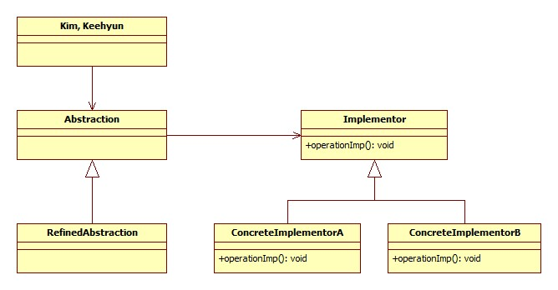

**Advantages / Disadvantages:**

Adv:- Decoupling abstraction from implementation, Interface and implementation can be varied independently   
- Reduction in the number of sub classes. For example, Image Viewer supports 6 image formats in 3 OS, using inheritance will result in 18 classes when using bridge result in 9 classes.

- Cleaner code and Reduction in executable size

- Improved Extensibility

- Loosely coupled client code, abstraction separate client code from the implementation so the implementation can be changed with no affect on the client code.

Disadv:

- Performance:Each bridge used add another function call which can negatively affect the performance.

-complexity: harder to debug if a problem arise.

**Example:**

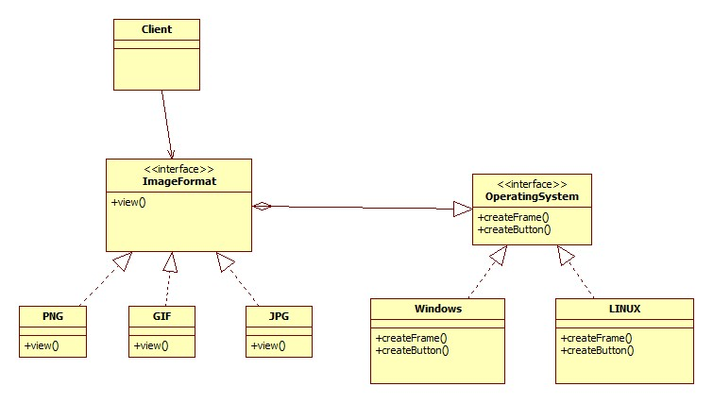

**Related Pattern:**

**Abstract factory:** An Abstract Factory pattern can be used create and configure a particular Bridge

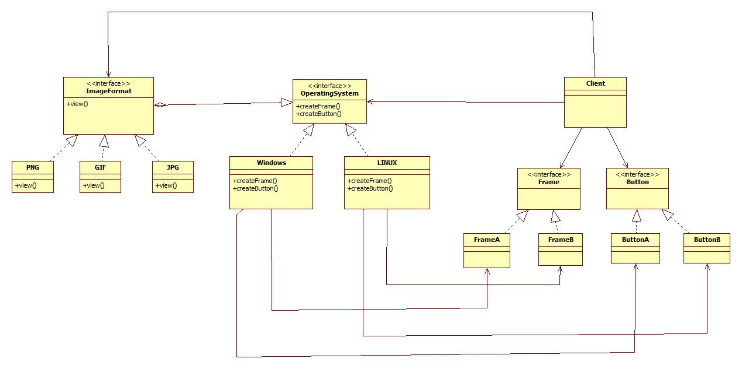

**Alternate Pattern /why it is a better choice:**

Adapter and Bridge has some common points, both make use of indirection through another object to allow high flexibility and they use an interface to sends request to the object.

Adapter resolves incompatibility between interfaces without having to reimplement any which can cause replicating code. Whereas, Bridge create a stable interface to client despite the variation of class that implement it and it accommodates new implementations as the system evolves. In a software life-cycle, engineers use Bridge when they can foreseen that an abstraction must have many implementations and both evolves independently while Adapter is use when unexpected classes need to work together even if they are incompatible.

In short, Bridge make them work when the system is designed and adapter resolve the problem when implementing the system.